Ip addr show

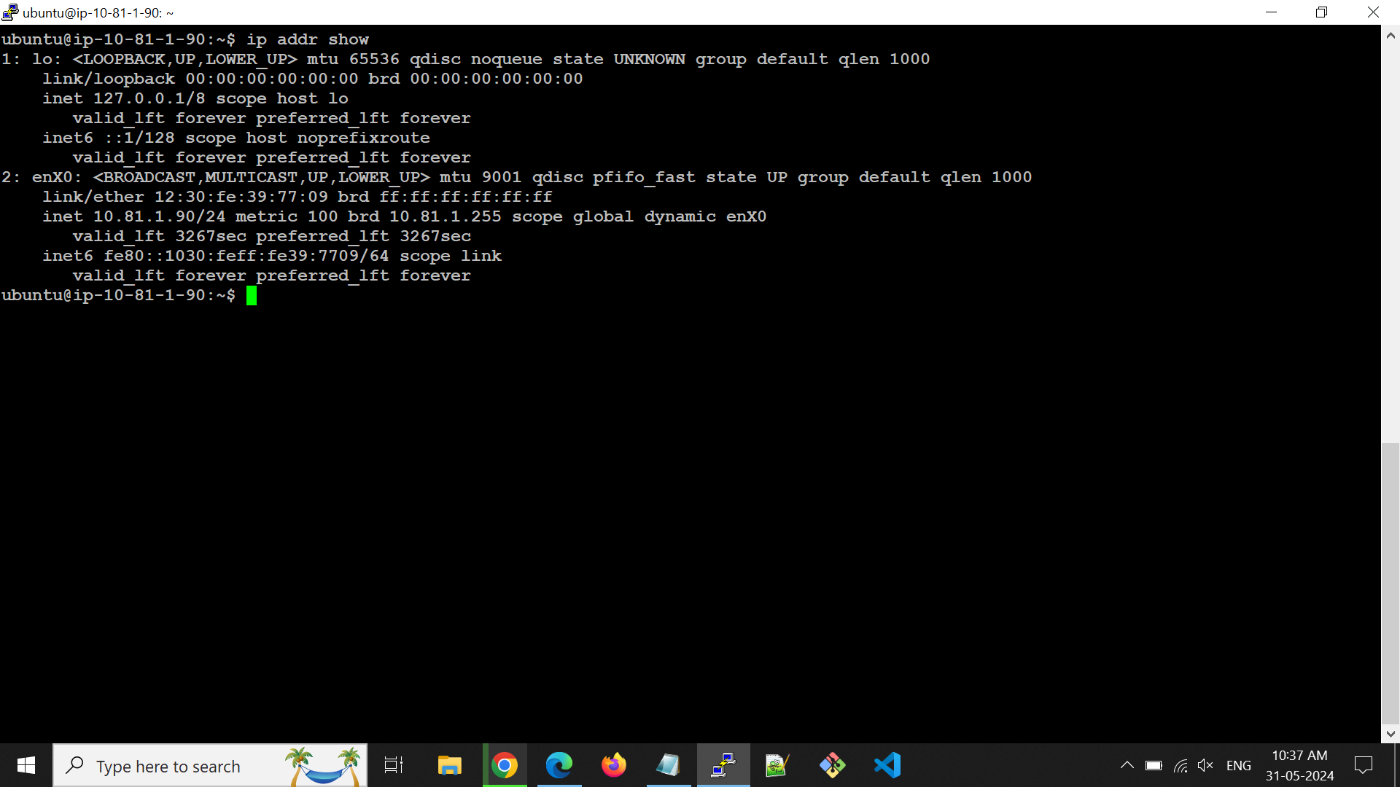

Ip route

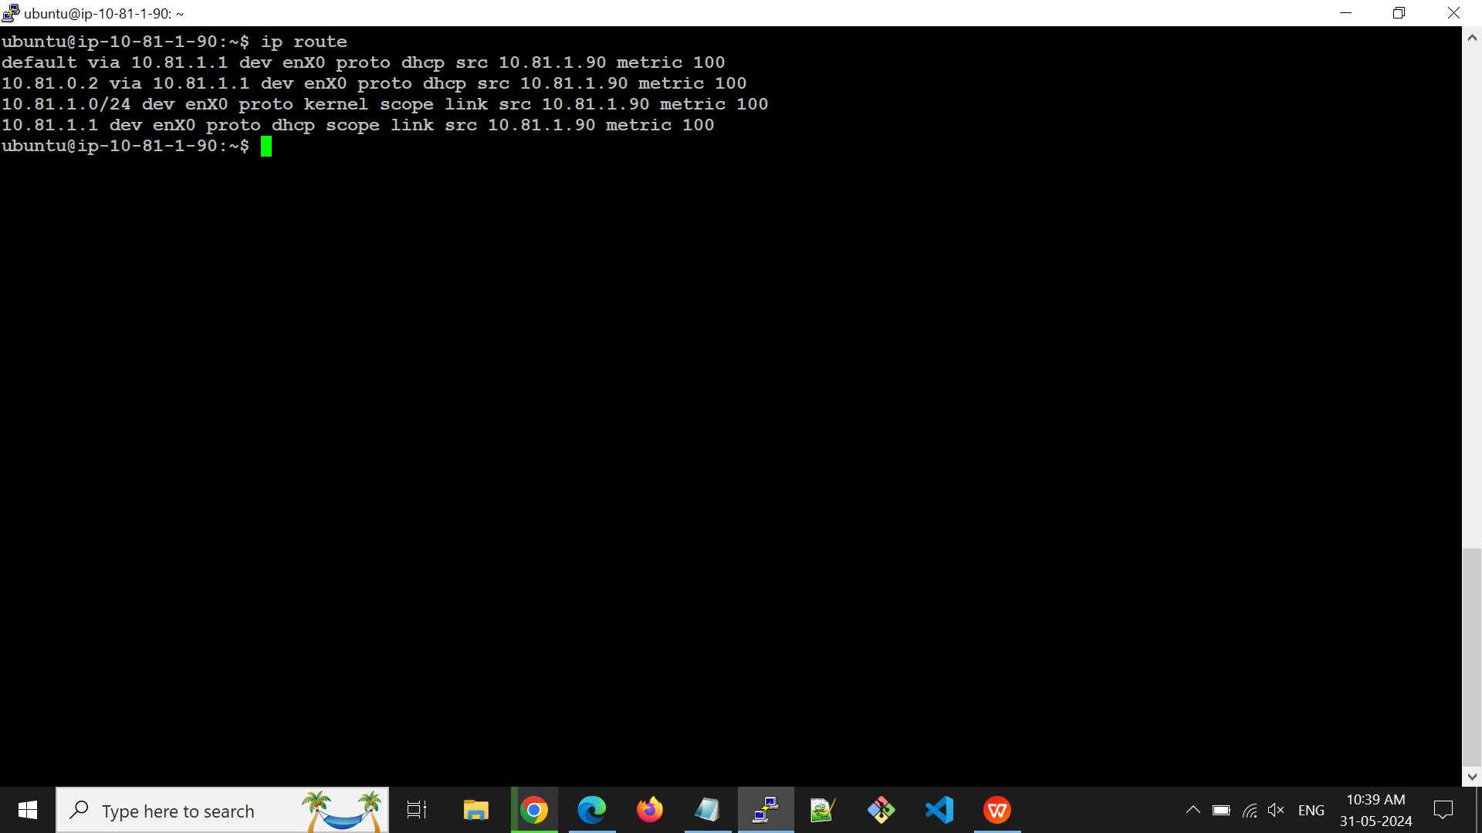

Create VPC and Subnet.

Assign the static IP to private Subnet Instance.